|  |  |
| --- | --- |
| **DATE** | **24.01.2023** |
| **SUBMITTED BY** | **VISHNUPRIYAN S** |
| **TITLE / ROLE** | **Online Voting System** |

**EXERCISE NUMBER:4 REGISTER NUMBER:RA2111026050026**

**JOBS AND RESPONSIBILITIES FOR ONLINE E-VOTING SYSTEM:**

1.Project Manager: Responsible for overseeing the development and implementation of the online e-voting system. This person would be responsible for managing the project team and ensuring that the system is delivered on time, within budget, and meets all requirements.

2.Software Engineer: Responsible for designing, developing, and testing the online e-voting system. This person would need to have expertise in programming languages, software development methodologies, and system architecture.

3.Database Administrator: Responsible for managing the database that stores voter information and voting results. This person would need to have expertise in database design, management, and security.

4.Cybersecurity Specialist: Responsible for ensuring the security and integrity of the online e-voting system. This person would need to have expertise in cybersecurity best practices, network security, and data encryption.

5.User Experience Designer: Responsible for designing the user interface of the online e-voting system. This person would need to have expertise in user-centered design, graphic design, and user research.

6.Technical Support Specialist: Responsible for providing technical support to users of the online e-voting system. This person would need to have expertise in troubleshooting, problem-solving, and customer service.

7.Data Analyst: Responsible for analyzing the voting data collected by the online e-voting system. This person would need to have expertise in data analysis, statistics, and data visualization.

8.Legal Consultant: Responsible for ensuring that the online e-voting system complies with all relevant laws and regulations. This person would need to have expertise in election law, data privacy, and intellectual property law.

**RESPONSIBILITIES**

1.Ensuring Security: The online e-voting system must be secure and protected from hacking, tampering, and unauthorized access. Responsibility lies with the team that develops, tests, and maintains the system.

2.Managing Voter Information: The system must ensure the accuracy and confidentiality of voter information, including voter registration data and personal details. Proper handling of data is vital to ensure voter privacy.

3.Providing Accessibility: The system must be accessible to all voters regardless of any disabilities they may have. Ensuring this accessibility is vital to provide equal voting opportunities to everyone.

4.Ensuring User-Friendliness: The system must be easy to use and navigate for voters. The design and user interface should be straightforward and intuitive.

5.Maintaining Transparency: The online e-voting system should be transparent and accountable, with clear rules and procedures for voting and vote counting. This transparency builds trust in the system.

6.Verifying Authenticity: The system must be able to verify the authenticity of voters to prevent fraud and ensure that every vote is valid.

7.Maintaining Integrity: The system must maintain the integrity of voting results and ensure that votes are counted correctly. Responsibility lies with the team responsible for developing, testing, and maintaining the system.

8.Ensuring Legal Compliance: The system must comply with all relevant laws and regulations related to online voting. Responsibility lies with the team responsible for understanding and implementing these requirements.

GANTT CHART:

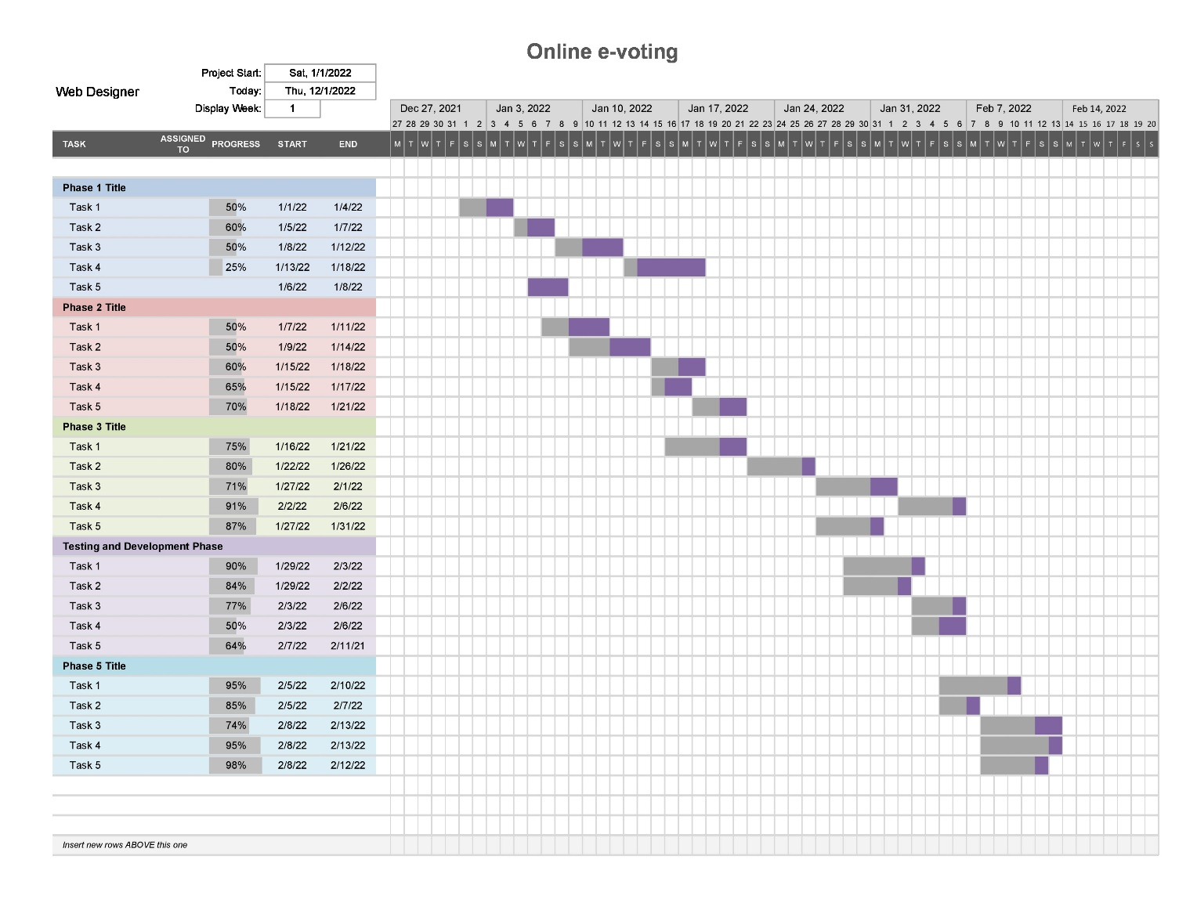

**CALCULATIONS:**

The Basic COCOMO model uses the following equation to estimate the effort required for a project:

Effort = a * (KLOC)^b

where a and b are constants specific to the type of project and the development environment. For an online e-voting system, we can use the following values for a and b:

a = 2.4 (for organic projects with a small team and a familiar development environment)

b = 1.05 (for projects with a relatively new programming language and a moderate level of complexity)

Using these values, we can estimate the effort required for the project as follows:

Effort = 2.4 * (200) ^1.05 = 715 person-months

This means that the project will require approximately 715 person-months of effort to complete. However, it is important to note that this estimate is based solely on the size and complexity of the project and does not take into account other factors that can affect the project's requirements, such as the skill level of the development team, the level of detail in the design, and the project's schedule and budget constraints. Therefore, this estimate should be used only as a rough guideline and should be refined as the project progresses